2022 Education Program for International Communities
at the National Museum of Korea

Overview
Title: | Traditional Korean Art Activity
Participants: | International schools and communities (25 or more persons per class*)  *The number of participants is negotiable during the COVID-19 pandemic (15 or more persons per class)
Date & Time: | Monday-Friday, year-round; 10 am-12 pm or 2 pm-4 pm (Time is negotiable)
Duration: | 2 hours
Language: | Korean or English
Fee: | Free (Separate material costs apply)
Content: | Korean pottery, painting, lacquerware, seal, calligraphy, and metal art (Choose one)
Contact: | Young Park (arahan10@korea.kr)

Program Details
Programs | Korean Pottery | Korean Painting | Korean Lacquerware
Details | Make a piece of buncheong ware or porcelain. | Draw birds and flowers in a Korean style. | Make a lacquerware mirror with inlaid mother-of-pearl.
 | 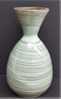  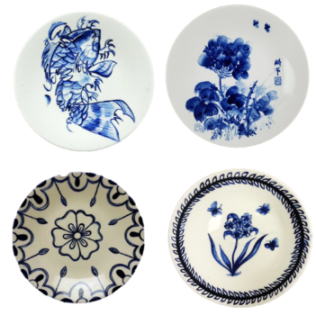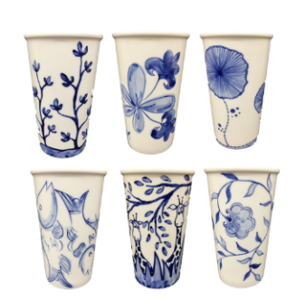 | 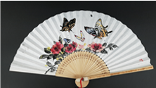  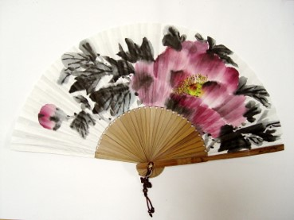  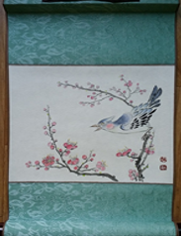 | 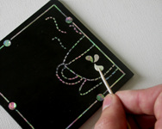  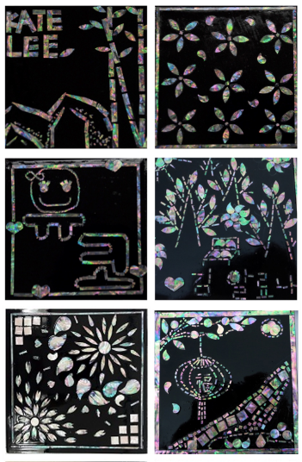
Material Cost per Person  (KRW) | ▪ Buncheong ware: 8,000  ▪ Porcelain plate: 5,000  ▪ Porcelain tumbler: 5,000 | ▪ Fan: 5,000  ▪ Hanging scroll: 6,000 | ▪ Laquerware mirror: 6,000
Programs | Korean Seal | Korean Calligraphy | Korean Metal Art
Details | Make a seal using traditional carving techniques. | Write calligraphy in Hangeul on hanji paper and make a notebook or hanging scroll. | Decorate a mirror or small box lid with a traditional metalwork technique.
 | 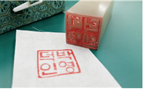  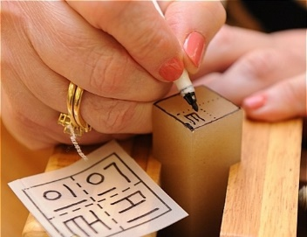  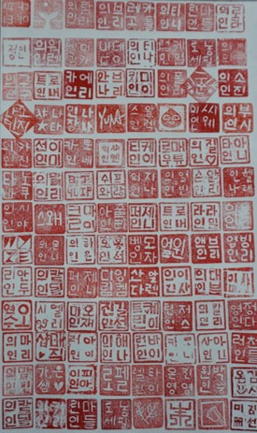 | 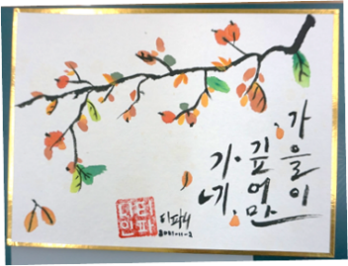  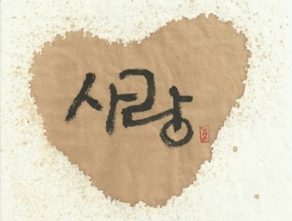  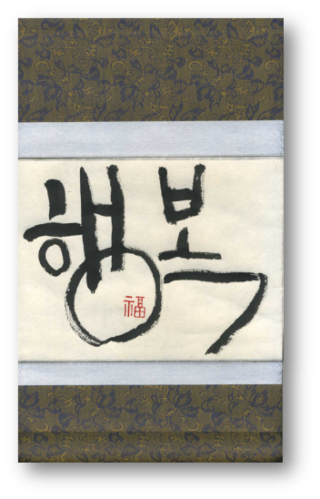 | 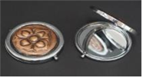  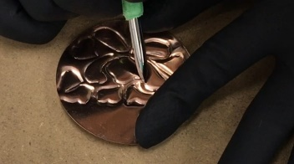  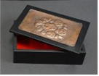  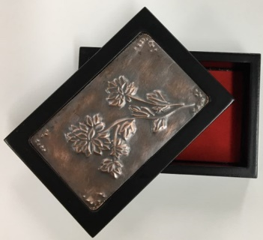
Material Cost per Person  (KRW) | ▪ Seal: 5,000 | ▪ Hanging scroll: 5,000  ▪ Notebook: 5,000 | ▪ Mirror: 5,000  ▪ Small box lid: 9,000

* Material costs may change due to circumstances.
* For the pottery class, your craftwork will be delivered after the baking process.
- It takes one month for buncheong ware and two weeks for porcelain.
* The programs are provided in Korean or English.

2022 Participation Request Form for Education Programs
(International Communities)
Organization | Name
 | Address
 | Phone No.
Contact | Name
 | Job Position
 | Mobile No.
 | E-mail
Participants | Age & Grade
 | Nationality
 | Number of Participants
 | Korean Language  Proficiency Level | □ Beginner  □ Intermediate  □ Advanced
Program  (Choose One) |  | □ Make Korea! (Pottery)  □ Buncheong ware  □ Porcelain dish  □ Porcelain tumbler  □ Draw Korea! (Painting)  □ Fan  □ Canvas  □ Inlay Korea! (Lacquerware)  □ Carve Korea! (Seal)  □ Write Korea! (Calligraphy)  □ Notebook  □ Hanging scroll  □ Hammer Korea! (Metalwork)  □ Hand mirror  □ Box
Date & Time |  | 1st Choice | Date: MM – DD / Time: 00:00 - 00:00
 |  | 2nd Choice | Date: MM – DD / Time: 00:00 - 00:00
 |  | 3rd Choice | Date: MM – DD / Time: 00:00 - 00:00
Additional Requests
The organization hereby applies for participation in the National Museum of Korea’s program,
“Traditional Korean Art Activity” 2022.

Date: 2022 – MM - DD

Head of the Organization: (Name) Signature or Seal:

ATTN: Director General, National Museum of Korea
Consent for Collection and Use of Personal Information on
Application for a Foreigner Education Program

The National Museum of Korea would like to obtain consent for collecting and using your personal information to proceed with your application for participating in a foreigner education program. Please read the contents carefully and show your consent.

Details of Collection and Use of Personal Information (Required)
Items | Purpose | Retention Period
Name, Mobile Phone Number | Participation request for joining educational program | 2(Two) Years
※ You have the right to refuse the collection and use of the above personal information. However, if you refuse to consent, your use of service may be restricted.

• Do you agree to collect and use the personal information as shown above?

Agree |  |  | Disagree

Details of Collection and Use of Personal Information (Optional)
Items | Purpose | Retention Period
Job Position, E-mail Address | Promotion of educational program for foreigners | 2(Two) Years
※ You have the right to refuse the collection and use of the above personal information. However, if you refuse to consent, your use of service may be restricted.

• Do you agree to collect and use the personal information as shown above?

Agree |  |  | Disagree

Date: 2022 – MM – DD

Applicant’s name: Signature or Seal:

ATTN: Director General, National Museum of Korea

